1. What is an EIP

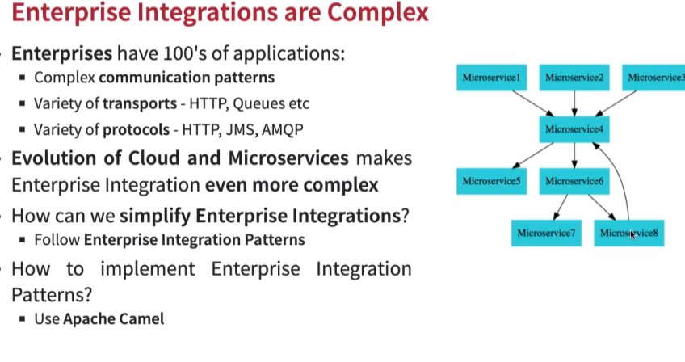
2. What is Apache Camel

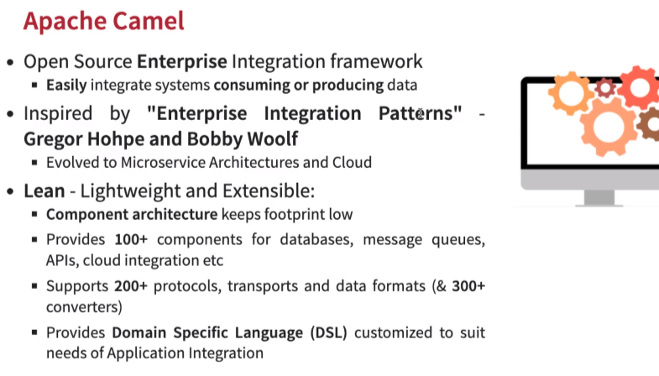

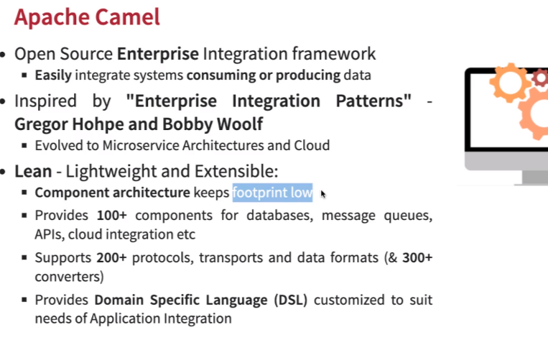

3. Some startup routes are present here: https://github.com/codingconquerors/apache-camel-springboot/tree/release/camel-microservice-source

4. Next step is to create a sender camel route for Active MQ. For this we need to first laucnh activemq from docker with this command:

>docker pull rmohr/activemq OR
>docker run -p 61616:61616 -p 8161:8161 rmohr/activemq

The JMX broker listens on port 61616 and the Web Console on port 8161.

